Title: Introduction to VLSI Design Flow and Basic Digital Logic Implementation
Intern Name: Lagisetty Vidya Charan
College: Mohan Babu University
Department: Electronics and Communication Engineering
Internship: VLSI Internship – Task 1
Objective:
The objective of this task is to understand the fundamentals of VLSI, learn the complete VLSI design flow, study basic digital logic gates, and implement simple combinational circuits using a logic simulator. This task provides the foundation required for RTL design and Verilog-based development.
Introduction to VLSI:
Very Large Scale Integration (VLSI) is the process of integrating millions or even billions of transistors onto a single semiconductor chip. It enables the design and fabrication of compact, high-performance, and low-power integrated circuits. VLSI technology is widely used in modern electronic systems, including processors, memory devices, communication systems, and embedded applications.
Applications of VLSI:
VLSI technology is widely used in many industries, including:
- Smartphones and tablets
- Computers and laptops
- Automotive electronics
- Medical devices
- Artificial Intelligence hardware
- Internet of Things (IoT)
- Consumer electronics
- Communication systems
- Aerospace and defense
VLSI Design Flow:
1. System Specification
The required functionality, performance, power consumption, and area constraints of the chip are defined.
2. Architecture Design
The overall architecture of the system is developed by dividing the design into functional blocks.
3. RTL Design
The hardware functionality is described using Hardware Description Languages (HDLs) such as Verilog or VHDL.
4. Functional Verification
The RTL design is simulated to verify that it behaves according to the specifications.
5. Synthesis
The RTL code is converted into a gate-level netlist using standard cell libraries.
6. Physical Design
The physical layout of the chip is created through floorplanning, placement, clock tree synthesis, and routing.
7. Timing and Power Analysis
Timing constraints and power consumption are analyzed to ensure reliable operation.
8. Fabrication
The final layout is sent to a semiconductor fabrication plant where the chip is manufactured.
9. Testing and Validation
The fabricated chip is tested to verify that it functions correctly and meets all specifications.
Basic Logic Gates:
- AND Gate

Boolean Expression: Y=A.B
Truth Table:
A | B | Y
0 | 0 | 0
0 | 1 | 0
1 | 0 | 0
1 | 1 | 1
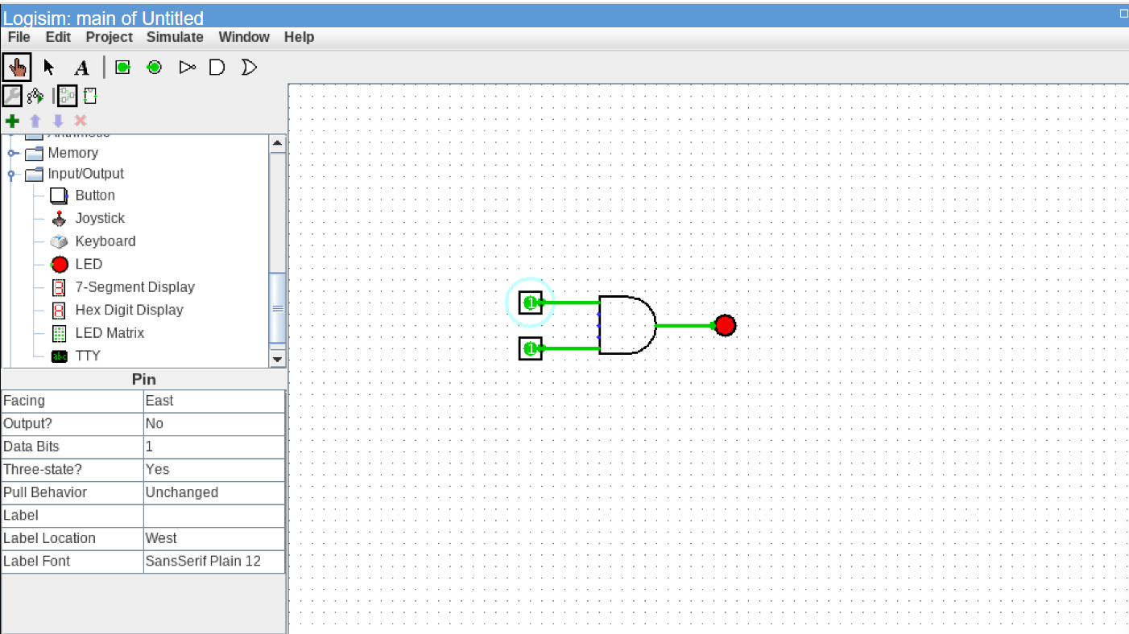

Fig: AND Gate simulated in Logisim
- OR Gate:

Boolean Expression: Y=A+B
Truth Table:
A | B | Y
0 | 0 | 0
0 | 1 | 1
1 | 0 | 1
1 | 1 | 1
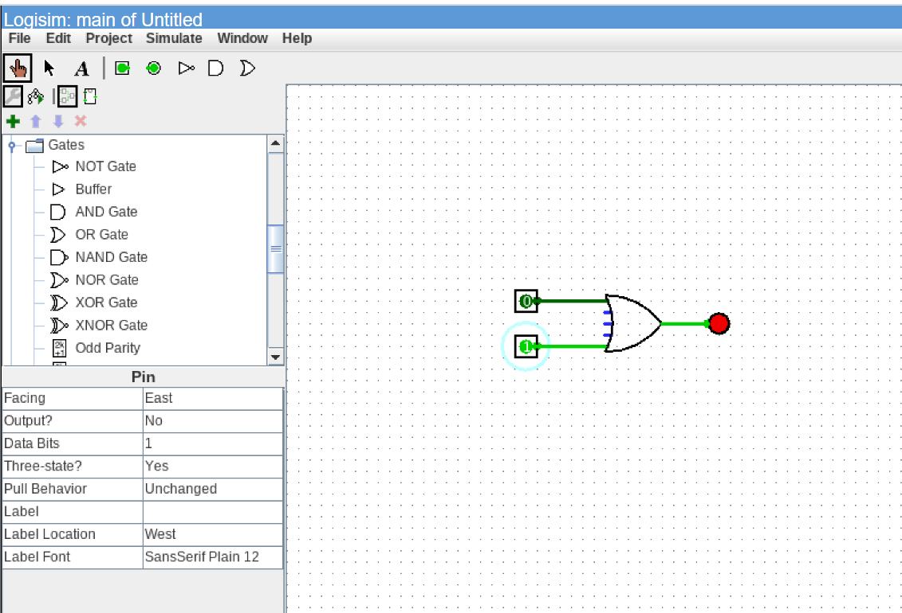

Fig: OR gate simulated in Logisim
- NOT gate:

Boolean Expression: Y=A’
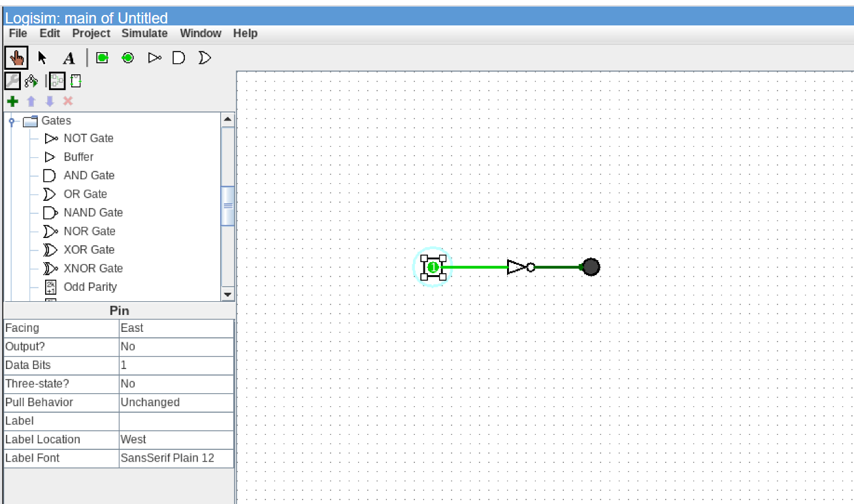
Truth Table:
A | Y
0 | 1
1 | 0
Fig: NOT gate simulated in Logisim

- NAND Gate:

Boolean Expression: Y=(A.B)’
Truth Table:
A | B | Y
0 | 0 | 1
0 | 1 | 1
1 | 0 | 1
1 | 1 | 0

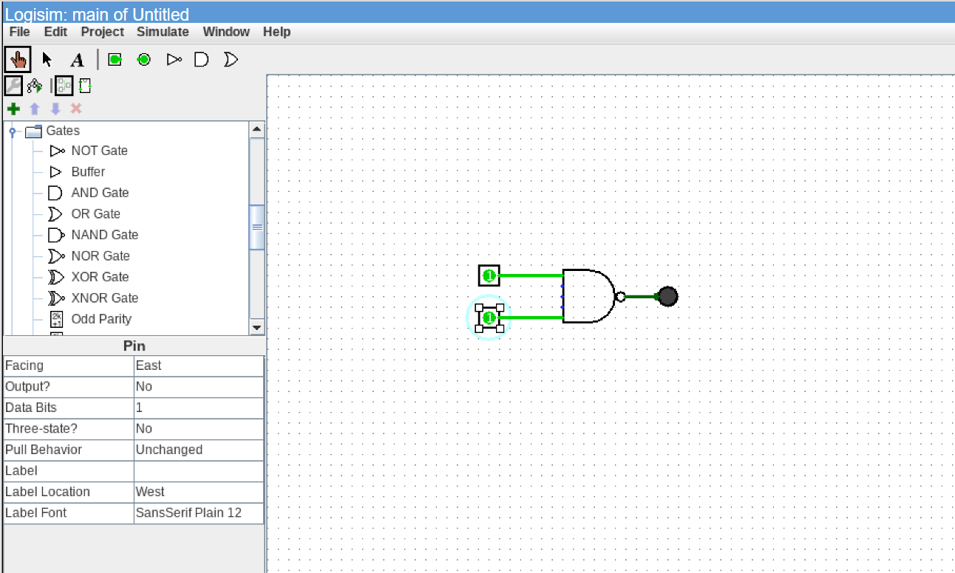
Fig: NAND gate simulated in Logisim
- NOR Gate:

Boolean Expression: Y=(A+B)’
Truth Table:
A | B | Y
0 | 0 | 1
0 | 1 | 0
1 | 0 | 0
1 | 1 | 0

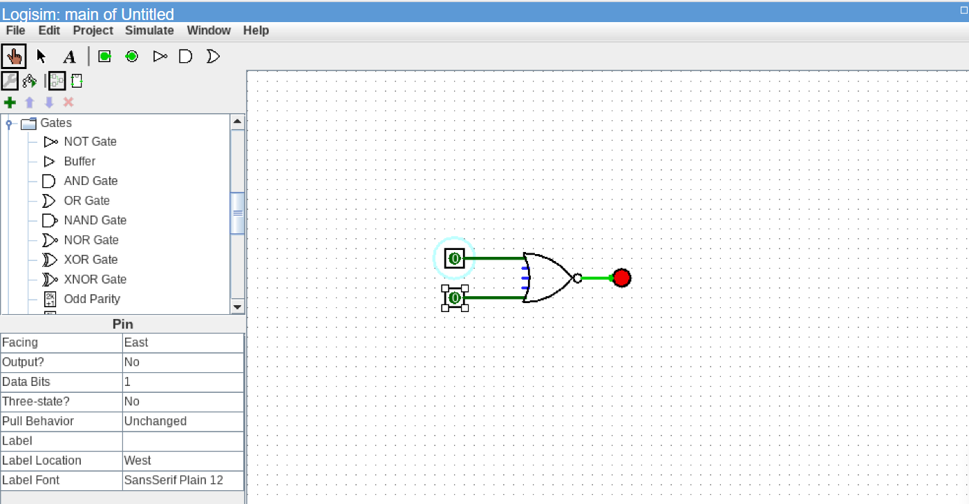
Fig: NOR gate simulated in Logisim
- XOR Gate:

Boolean Expression: Y = A ⊕ B
Truth Table:
A | B | Y
0 | 0 | 0
0 | 1 | 1
1 | 0 | 1
1 | 1 | 0
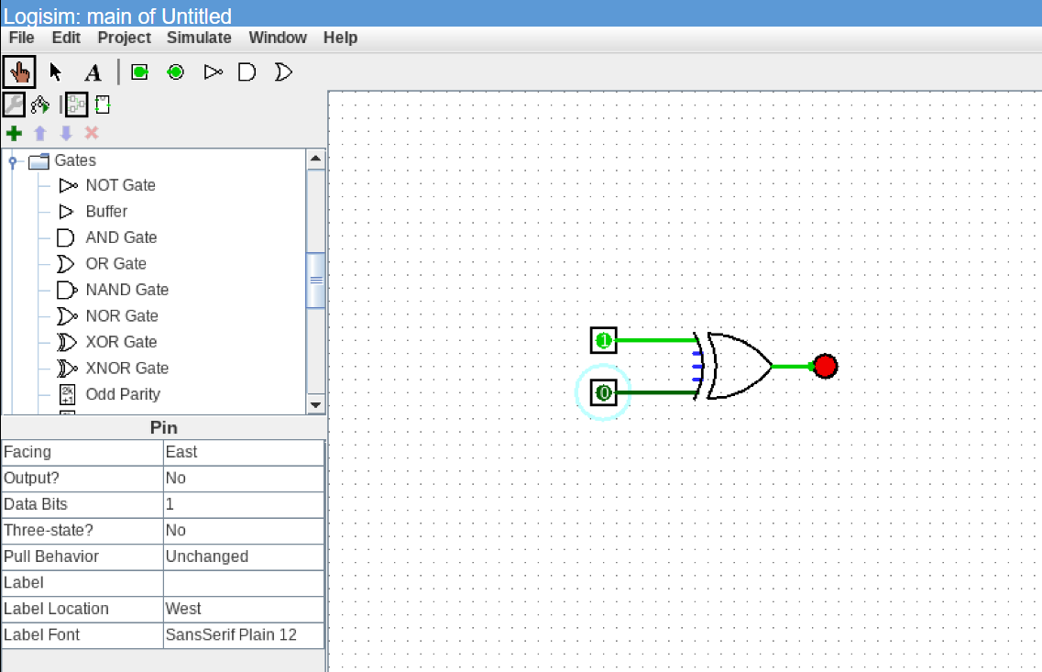

Fig: XOR gate simulated in Logisim

- Half Adder:

Boolean Expressions:
Sum= A ⊕ B
Carry= A.B
Truth Table:
A | B | Sum | Carry
0 | 0 | 0 | 0
0 | 1 | 1 | 0
1 | 0 | 1 | 0
1 | 1 | 0 | 1
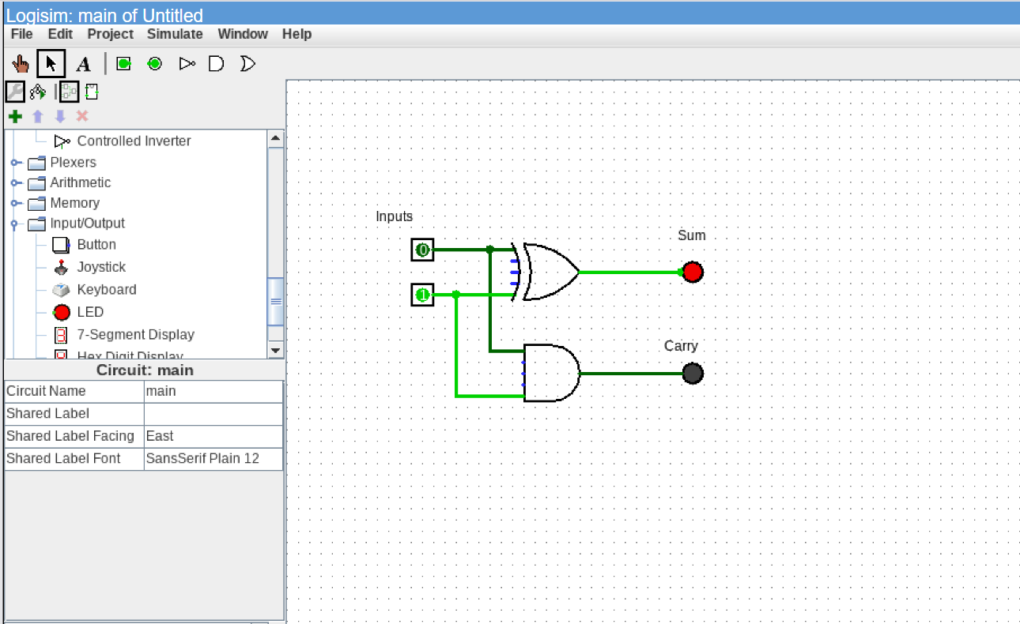

Observations:
- Successfully simulated all six basic logic gates.
- Verified the truth table for each logic gate using all possible input combinations.
- Designed and simulated a Half Adder using XOR and AND gates.
- Observed that the simulation outputs matched the expected theoretical results.
- Gained practical understanding of digital logic implementation and combinational circuit design.

Conclusion:
Task 1 provided a strong foundation in VLSI fundamentals and digital logic design. The complete VLSI design flow was studied, and the operation of basic logic gates was verified through simulation. A Half Adder circuit was also implemented successfully. This task enhanced practical knowledge of digital circuits and prepared the foundation for future RTL design and Verilog-based tasks.

